

# Root and Rhythm

Rooted in care. Styled with rhythm.

# Smart Product Choices

## Product Ingredients Checker

Highlights harmful chemicals, suggests safer alternatives.

## Ingredient Safety Checker

Determines if kitchen ingredients are safe for hair.

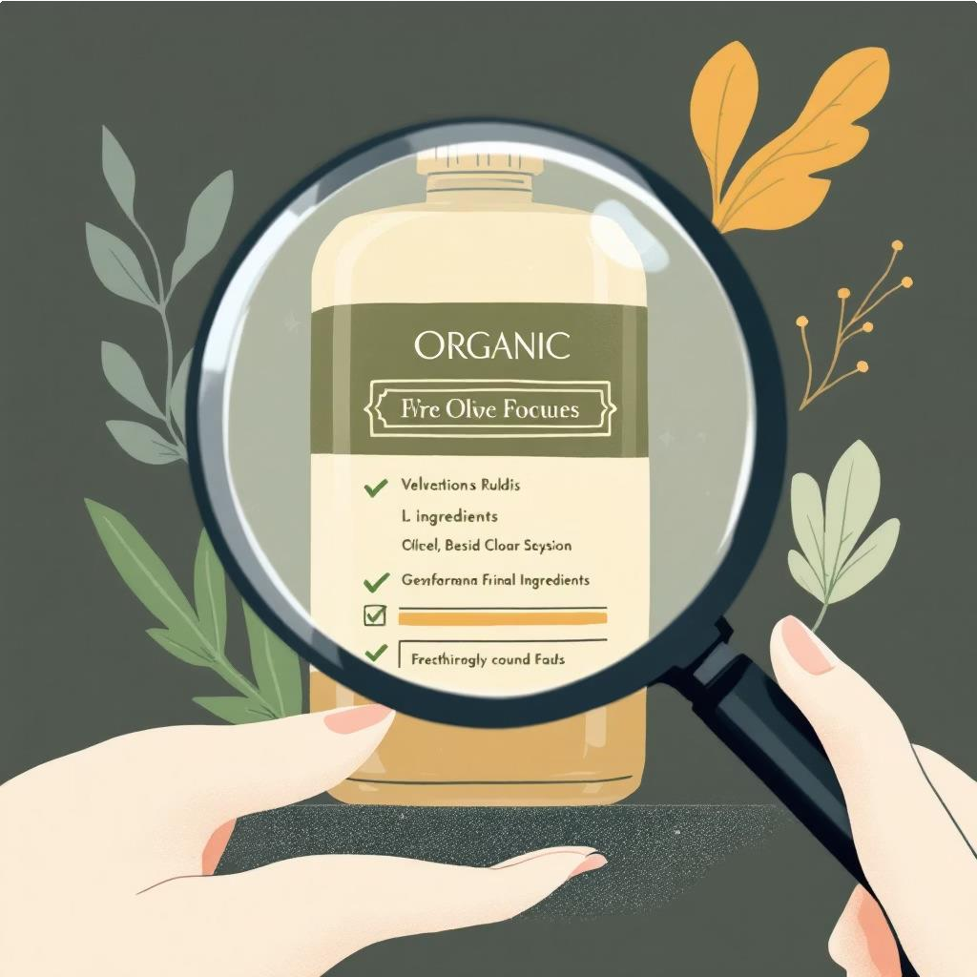 

# Virtual Style Transformation



Virtual tool to try on new hair colors.

Hairstyle suggestions based on face shape.



Track Your Hair Journey

## Hair Routine Planner



Track oiling, wash days, masks, growth, products.

## Heat Damage Calculator

Estimates damage based on temperature and frequency.



# Curly Hair Mastery



Gel cast guide, curl pattern quiz.

Product Comparison & Community

## Natural vs. Store Product Comparer

Helps choose between DIY and commercial products.

## Hair Growth Community

Share progress, routines, and tips with others.

 



# Styling Guides

## Blow-Dry Style Guide



Steps for Korean C-curl, waves, volume, and more.

# Your Complete Hair Journey

From problem-solving to styling, Root and Rhythm empowers your hair care.

